Add cover Add comment

**Ideal Swings Conditions For Any Market**

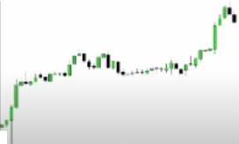

F,rn \I ,rL r '"' 1 ld, l f,,, , n,p,

·- _

'.. ' " .....'.........4 ......

lop,O" . ,a••••

""'' ol.,,l ...

101,""'

.,.,..

\\hJt I, Th C,,,,

I: T• •tm;:'

, .. o ". ·.,• '•••

.... ,.,......

*\\h*.*.*.*,*.·"""'" lr•dint'

.........•.no h< "•• • ,,_ "'• •,

ll•

,.--,, ..., ,

, ...,.

'"""'······

'"" '" ................, .,.,,....

""'""

'. ....." ..., .... " ..

,., .•. ,, ••.•• , •.,4.,., ..

l..t,,n""

,

""'

11,,,j • •••d••• 1.,1 ,,,-.-,

,., '"' '

,O I '•

I, IO o-, «

* ••I '' l I

I ,...,,, 0 ,,,,.,,..,...,,.,

"" , . .,. '

.\larket Profile \htltt>n,:



**Consolidation**

**{Trending} Reversal**

**Consolidation Trending Reversal**

\larl..l·h moH· rrnm orw prufik lo fin· rw,1 - in alllimdraml'\.

On \lnnlhh :.ind \h•t"l..h ch:irt, lool;. for lhl' curn·nl \larl..l•f Profill·forHmrnlllrl..el\of

,111d .

\,uiil lcnl..lu,t,-r "I l.-th.1n:il 111;1d,,·1' lh;it h.l\, liUk lu 11u 111◄"u11u1I in 111,· la,I _\ munth,

When we leave a consolidation area, chances are were going to be in a trending enviroment Trending markets have funds behind them

Avoid consolidating markets, theres a lack of buying and selling

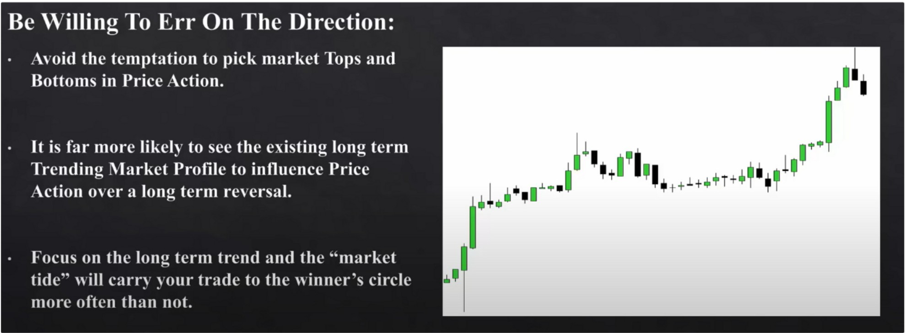

Avoid your brain to tell you that it wants to reverse, follow the trend If it gives you losses, then its likely making a shift

And just because the monhtly moves higher doesnt mean theres a setup, theres other things to look for as well

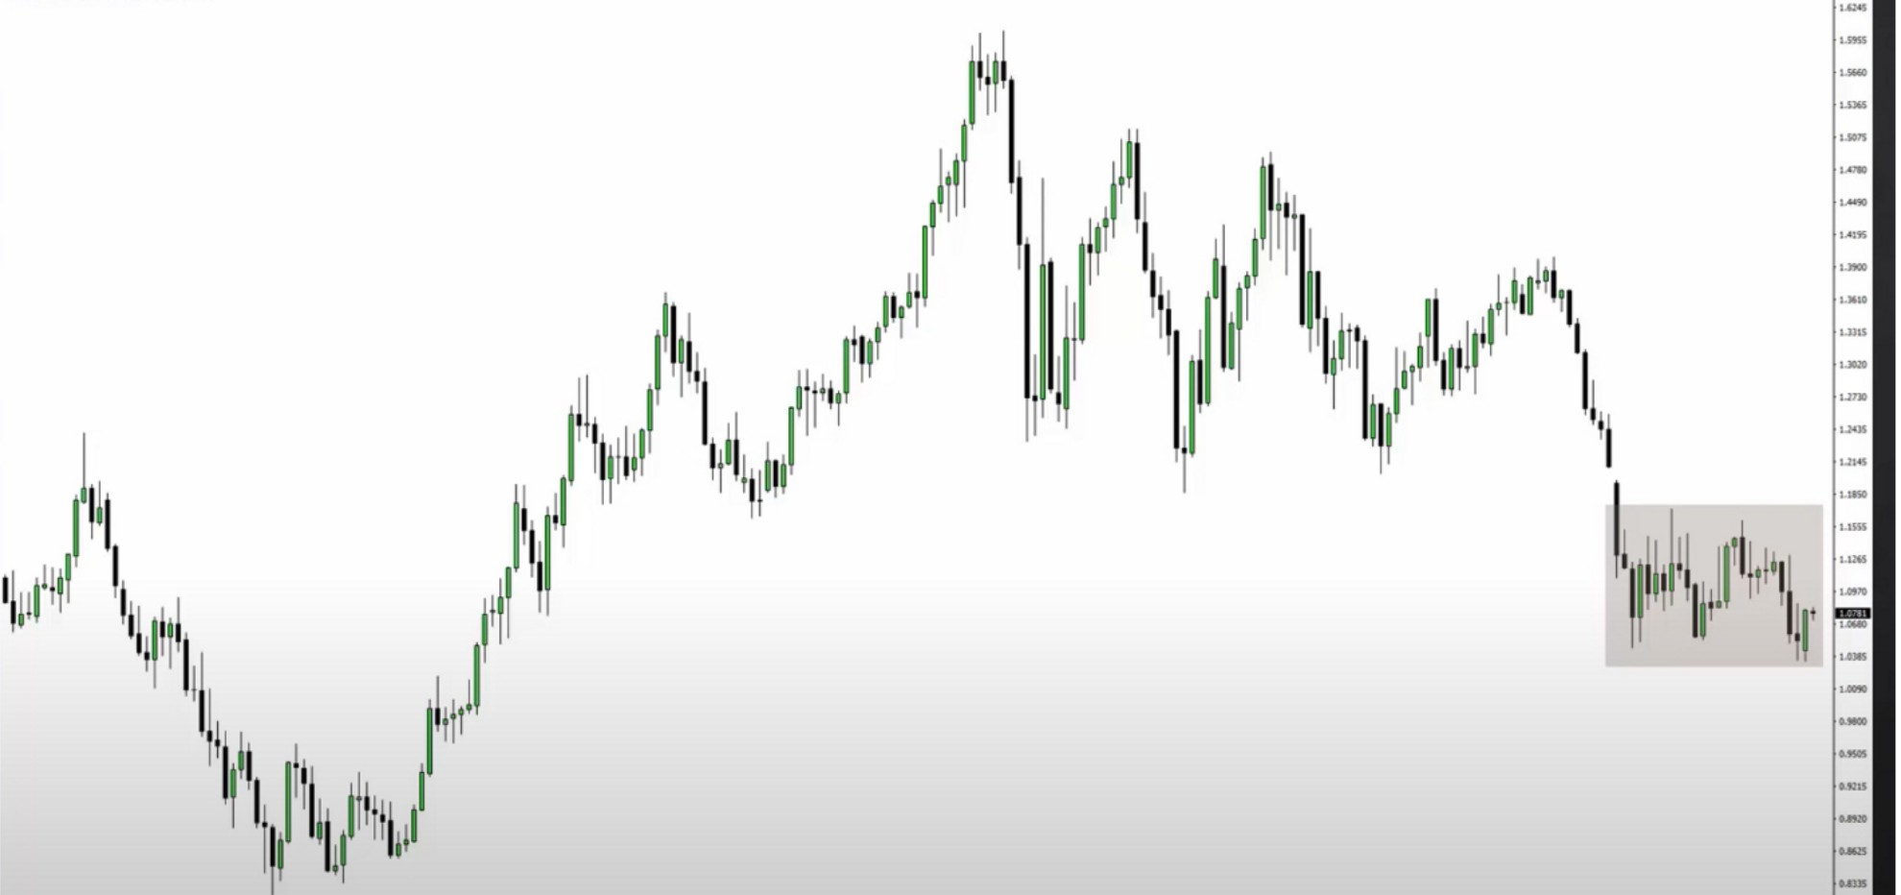

--

**IM-**

•--

•-•- **IM-** •-- •-- **11"1-** •-- •-- **IM-** •-- •-- **1M-** •-- •-- **IM-** •-- •-- **IM-** •--• •--• **IMIIU I-al** I-al **IM- 1-&I** •-- **IM-**

Consolidation profile

Consolidation profiles are tradeable, but its not for swing trading you want to be looking for a trending market for swing trading

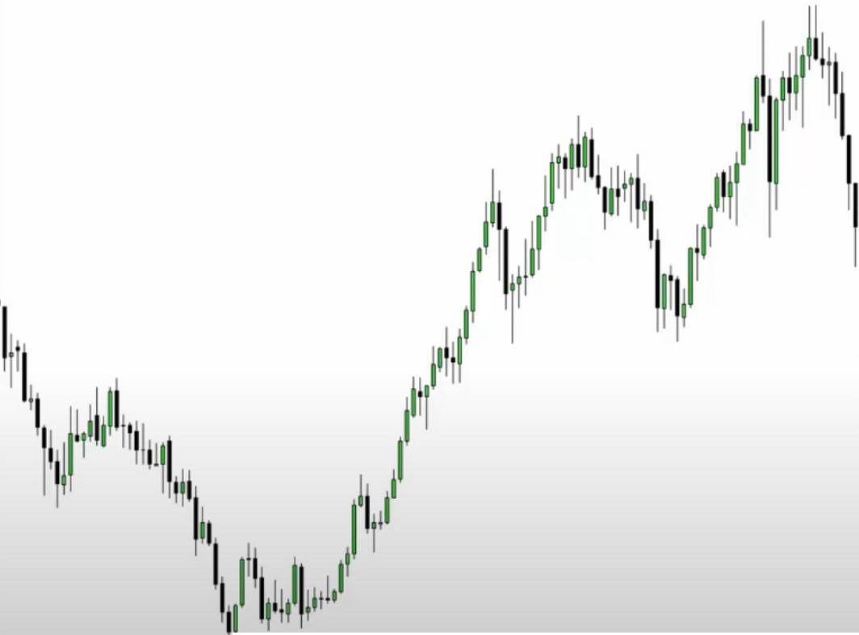

I

111111

i11,1*1*jllI

**I 1111**

1111 1111111

'ii

1 I'

II

II

i11i11

:

*I*

:

111 11'1r;

I

-

**l',-------c,-- ,w--,- -** ,- -**, w- ,-- ,-- ,w--,-** ,**-**- -**, w- ,-- ,-- ,w--,-** ,**-**- -**, w- ,-- ,-- ,w--,- .**,**,**- -,**, w- ,-- ,-- ,w--,- .**,**,**- -**,=-,--'w-**-

*�t �*

-

Trending profile

It shows a willingness to leave a consolidation, thats very strong for swing trading

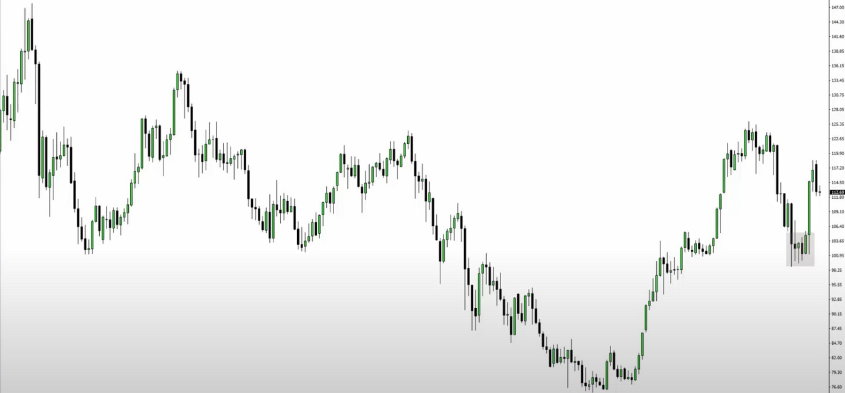

1-"" u.1. ,. 1,..,.,.. ,_.,,. 1,.._ •--

, .,.._ ,,.._ **1--** ,,.._ 1-- •-- ,,.._ •-- , **,u_** , 1-- ,,.._ 1-•1 •-•1 **,,..lllll , ... .u** , , ,,.._ ,,..., 1-•• **1u•1**

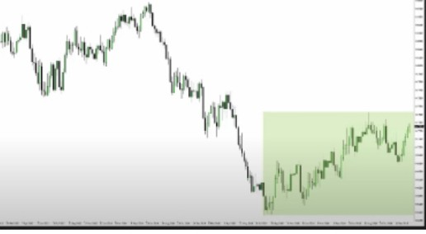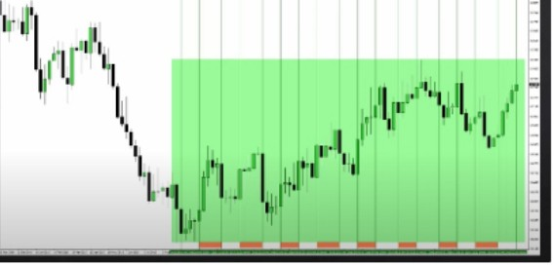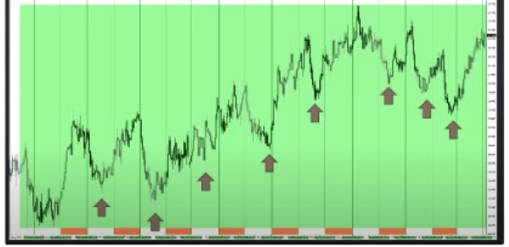

Each line is a new month

You hold swing trades for about 2 weeks or longer, this gives you an idea of where you want to get involved

We look for strong trending plays, you can combine this with month 5 the long term position trading month and build long term positions and swing trade positions

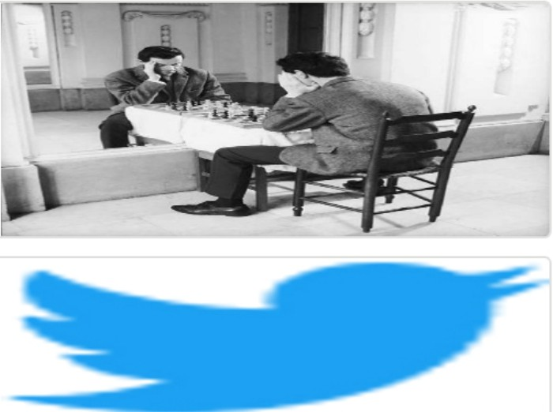Arjo I Twitter, lnstagram I Linktree

Linktree. Make your link do more. https://t.co/HhmmTN1fUI

JavaScript is not available.

***"JI*** https://twitter.com/arjoio